**Project 3 - Initial plan**

**Topic : Coffee Analysis and Predictions**

* Coffee Production
* Coffee Consumption
* Coffee Quality
* Climate, Latitude and Altitude

**Questions**

Which all are the Top Coffee Producing Countries?

Which all are the Top Coffee Importing Countries?

Change in production over the years.

Coffee price over the time around the World

Predicting the Species (Arabica, Robusta) of Coffee from the Quality Measures

**Data Sources**

Kaggle: https://www.kaggle.com/volpatto/coffee-quality-database-from-cqi

International Coffee Organization (ICO): http://www.ico.org

**Sample Dataset**

################### Quality Measures ####################

# Aroma

# Flavor

# Aftertaste

# Acidity

# Body

# Balance

# Uniformity

# Cup Cleanliness

# Sweetness

# Moisture

# Defects

################### Bean Metadata ####################

# Processing Method

# Color

# Species (arabica / robusta)

################### Farm Metadata ####################

# Country of Origin

# Altitude

**Targets/Labels for ML:** Species, Country of Origin

**Variables/Features:** Aroma, Flavor, Aftertaste, Acidity, Body, Balance, Uniformity, Cup Cleanliness, Sweetness, Moisture, Defects

**Algorithm/Model type** : Decision Tree

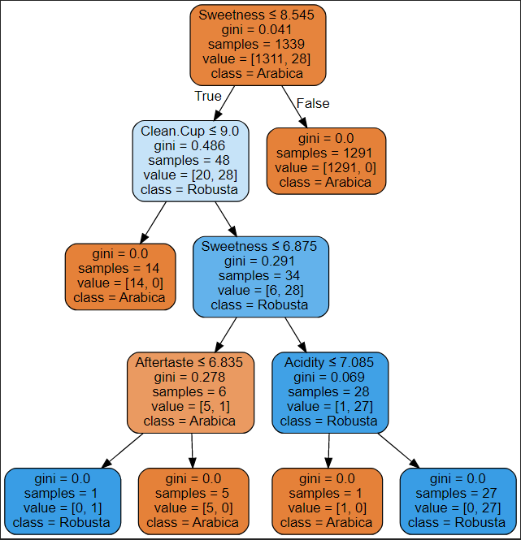

Fig: Sample decision tree structure